**LAPORAN TUGAS BESAR KOMPUTER GRAFIKA**

**MEMBUAT OBJEK 3D STADION SEPAK BOLA**

**Kelompok 1 IF-9 VIII**

**Anggota:**

**DADANG SASMITA 10108433**

**SIGMA REFFANZA D 10108440**

**DANI HARDIANTO S 10108457**

**ALI YAPI 10108456**



**JURUSAN TEKNIK INFORMATIKA**

**FAKULTAS TEKNIK DAN ILMU KOMPUTER**

**UNIVERSITAS KOMPUTER INDONESIA**

**2012**

**1. PENDAHULUAN**

**1.1 Latar Belakang**

Olah raga sepakbola dewasa ini makin populer dikalangan masyarakat Indonesia. Dapat dirasakan dengan adanya dua kompetisi liga yang membuat dunia persepakbolaan Indonesia dilanda masalah. Kemudian akan segera dimulainya salah satu liga bergengsi di Eropa yaitu Euro pada 2012. Masyarakat Indonesia tentu sangat antusias dengan akan berlangsungnnya kompetisi besar di Eropa itu. Liga tersebut tentu tidak lepas dari stadion-stadion megah yang menghiasi disetiap pertandingannya.

Dari paparan singkat diatas kelompok kami memiliki ide untuk membuat sebuah stadion sepakbola.

**2. ISI**

**2.1 Ide**

Untuk tugas besar komputer grafika ini kelompok kami memiliki ide objek untuk membuat Stadion Sepak Bola dengan objek 3D. Ide objek yang ada dalam Stadion Sepak Bola ini adalah :

* Lapangan
* Garis Lapangan
* Tiang gawang
* Tribun penonton
* Papan Skor
* Bendera pojok
* Tutup Tribun

**2.2 Perancangan**

Untuk tahap perancangan pembuatan objek yang dibangun adalah :

1. Mengumpulkan data objek yang akan dibangun

2. Menganalisis objek-objek yang akan dipakai

3. Membuat desain objek 3D

**2.3 Implementasi**

Dalam pelaksanaan proses pembuatan objek 3D ini, kami memerlukan perangkat keras dan perangkat lunak untuk menyelesaikan tugas besar ini.

**2.4 Perangkat Keras (*hardware*)**

Spesifikasi perangkat keras yang digunakan untuk pembuatan objek 3D ini meliputi :

a. Komputer berspesifikasi minimal intel pentium 3

b. *Harddisk* 50 Gb

c. *RAM* 1Gb

d. Keyboard

e. Mouse

**2.5 Perangkat Lunak**

Spesifikasi perangkat lunak yang digunakan untuk membuat objek 3D ini adalah :

a. Sistem Operasi : *Microsoft Windows XP*

b. Program Aplikasi : Dev C++

c. Program pembangun : Open GL

**2.6 Kegiatan Implementasi**

Kegiatan Implementasi ini antara lain meliputi :

1. Pemrograman

2. Pengujian Objek 3D

**3. SOURCE CODE**

/*

DADANG S 10108433

SIGMA REFFANZA DWIJAYA 10108440

ALI YAPI 10108456

DANI HARDIANTO SETIAWAN 10108457

*/

#include <cstdlib>

#include <iostream>

#include <windows.h>

#include <GL/glut.h>

#include <GL/gl.h>

#include <stdlib.h>

using namespace std;

static int spin = 0;

static float lampu = 0.0;

void keyboard(unsigned char, int, int);

void display(void) {

int i, j;

glutSwapBuffers();

glClear(GL_COLOR_BUFFER_BIT | GL_DEPTH_BUFFER_BIT);

glColorMaterial(GL_FRONT, GL_SPECULAR);

//cahaya

GLfloat lightColor1[] = {1.0f, 1.0f, 1.0f, 1.0f}; //0.0f, 0.0f, -8.0f

GLfloat lightPos1[] = {0.75, 0.40, 0.0, 0.0};

glLightfv(GL_LIGHT1, GL_AMBIENT, lightColor1);

glLightfv(GL_LIGHT1, GL_POSITION, lightPos1);

glPushMatrix();

// TRIBUN

//atas

//tribun atas 1

glPushMatrix();

glColor3f(0.9, 1, 1);

glTranslatef(0, 1.5, 0.02);

glScalef(3.2, 0.05, 0.03);

glutSolidCube(2.0);

glPopMatrix();

//tribun atas 2

glPushMatrix();

glColor3f(0.5, 0.5, 0.5);

glTranslatef(0, 1.59, 0.04);

glScalef(3.3, 0.05, 0.05);

glutSolidCube(2.0);

glPopMatrix();

//tribun atas 3

glPushMatrix();

glColor3f(0.9, 1, 1);

glTranslatef(0, 1.68, 0.06);

glScalef(3.4, 0.05, 0.07);

glutSolidCube(2.0);

glPopMatrix();

//tribun atas 4

glPushMatrix();

glColor3f(0.5, 0.5, 0.5);

glTranslatef(0, 1.77, 0.08);

glScalef(3.5, 0.05, 0.09);

glutSolidCube(2.0);

glPopMatrix();

//tribun atas 5

glPushMatrix();

glColor3f(0.9, 1, 1);

glTranslatef(0, 1.86, 0.1);

glScalef(3.6, 0.05, 0.11);

glutSolidCube(2.0);

glPopMatrix();

//tribun atas 6

glPushMatrix();

glColor3f(0.5, 0.5, 0.5);

glTranslatef(0, 1.95, 0.12);

glScalef(3.7, 0.05, 0.13);

glutSolidCube(2.0);

glPopMatrix();

//tribun atas 7

glPushMatrix();

glColor3f(0.9, 1, 1);

glTranslatef(0, 2.04, 0.14);

glScalef(3.8, 0.05, 0.15);

glutSolidCube(2.0);

glPopMatrix();

//tribun atas 8

glPushMatrix();

glColor3f(0.5, 0.5, 0.5);

glTranslatef(0, 2.13, 0.16);

glScalef(3.9, 0.05, 0.17);

glutSolidCube(2.0);

glPopMatrix();

//tribun atas 9

glPushMatrix();

glColor3f(0.9, 1, 1);

glTranslatef(0, 2.22, 0.18);

glScalef(4.0, 0.05, 0.21);

glutSolidCube(2.0);

glPopMatrix();

//tribun atas 10

glPushMatrix();

glColor3f(0.5, 0.5, 0.5);

glTranslatef(0, 2.31, 0.2);

glScalef(4.1, 0.05, 0.21);

glutSolidCube(2.0);

glPopMatrix();

//Bawah

//tribun Bawah 1

glPushMatrix();

glColor3f(0.9, 1, 1);

glTranslatef(0, -1.5, 0.02);

glScalef(3.2, 0.05, 0.03);

glutSolidCube(2.0);

glPopMatrix();

//tribun Bawah 2

glPushMatrix();

glColor3f(0.5, 0.5, 0.5);

glTranslatef(0, -1.59, 0.04);

glScalef(3.3, 0.05, 0.05);

glutSolidCube(2.0);

glPopMatrix();

//tribun Bawah 3

glPushMatrix();

glColor3f(0.9, 1, 1);

glTranslatef(0, -1.68, 0.06);

glScalef(3.4, 0.05, 0.07);

glutSolidCube(2.0);

glPopMatrix();

//tribun Bawah 4

glPushMatrix();

glColor3f(0.5, 0.5, 0.5);

glTranslatef(0, -1.77, 0.08);

glScalef(3.5, 0.05, 0.09);

glutSolidCube(2.0);

glPopMatrix();

//tribun Bawah 5

glPushMatrix();

glColor3f(0.9, 1, 1);

glTranslatef(0, -1.86, 0.1);

glScalef(3.6, 0.05, 0.11);

glutSolidCube(2.0);

glPopMatrix();

//tribun Bawah 6

glPushMatrix();

glColor3f(0.5, 0.5, 0.5);

glTranslatef(0, -1.95, 0.12);

glScalef(3.7, 0.05, 0.13);

glutSolidCube(2.0);

glPopMatrix();

//tribun Bawah 7

glPushMatrix();

glColor3f(0.9, 1, 1);

glTranslatef(0, -2.04, 0.14);

glScalef(3.8, 0.05, 0.15);

glutSolidCube(2.0);

glPopMatrix();

//tribun Bawah 8

glPushMatrix();

glColor3f(0.5, 0.5, 0.5);

glTranslatef(0, -2.13, 0.16);

glScalef(3.9, 0.05, 0.17);

glutSolidCube(2.0);

glPopMatrix();

//tribun Bawah 9

glPushMatrix();

glColor3f(0.9, 1, 1);

glTranslatef(0, -2.22, 0.18);

glScalef(4.0, 0.05, 0.21);

glutSolidCube(2.0);

glPopMatrix();

//tutup tribun

//Bawah

glPushMatrix();

glColor3f(0.5, 0.5, 0.5);

glTranslatef(0, -2.31, 0.18);

glScalef(4.1, 0.05, 0.25);

glutSolidCube(2.0);

glPopMatrix();

//kiri

//tribun kiri 1

glPushMatrix();

glColor3f(0.9, 1, 1);

glTranslatef(-3.15, 0, 0.02);

glScalef(0.05, 1.4, 0.03);

glutSolidCube(2.0);

glPopMatrix();

//tribun kiri 2

glPushMatrix();

glColor3f(0.5, 0.5, 0.5);

glTranslatef(-3.25, 0, 0.04);

glScalef(0.05, 1.5, 0.05);

glutSolidCube(2.0);

glPopMatrix();

//tribun kiri 3

glPushMatrix();

glColor3f(0.9, 1, 1);

glTranslatef(-3.35, 0, 0.06);

glScalef(0.05, 1.6, 0.07);

glutSolidCube(2.0);

glPopMatrix();

//tribun kiri 4

glPushMatrix();

glColor3f(0.5, 0.5, 0.5);

glTranslatef(-3.45, 0, 0.08);

glScalef(0.05, 1.7, 0.09);

glutSolidCube(2.0);

glPopMatrix();

//tribun kiri 5

glPushMatrix();

glColor3f(0.9, 1, 1);

glTranslatef(-3.55, 0, 0.1);

glScalef(0.05, 1.8, 0.11);

glutSolidCube(2.0);

glPopMatrix();

//tribun kiri 6

glPushMatrix();

glColor3f(0.5, 0.5, 0.5);

glTranslatef(-3.65, 0, 0.12);

glScalef(0.05, 1.90, 0.13);

glutSolidCube(2.0);

glPopMatrix();

//tribun kiri 7

glPushMatrix();

glColor3f(0.9, 1, 1);

glTranslatef(-3.75, 0, 0.14);

glScalef(0.05, 2.0, 0.15);

glutSolidCube(2.0);

glPopMatrix();

//tribun kiri 8

glPushMatrix();

glColor3f(0.5, 0.5, 0.5);

glTranslatef(-3.85, 0, 0.16);

glScalef(0.05, 2.1, 0.17);

glutSolidCube(2.0);

glPopMatrix();

//tribun kiri 9

glPushMatrix();

glColor3f(0.9, 1, 1);

glTranslatef(-3.95, 0, 0.18);

glScalef(0.05, 2.2, 0.19);

glutSolidCube(2.0);

glPopMatrix();

//kanan

//tribun kanan 1

glPushMatrix();

glColor3f(0.9, 1, 1);

glTranslatef(3.15, 0, 0.02);

glScalef(0.05, 1.4, 0.03);

glutSolidCube(2.0);

glPopMatrix();

//tribun kanan 2

glPushMatrix();

glColor3f(0.5, 0.5, 0.5);

glTranslatef(3.25, 0, 0.04);

glScalef(0.05, 1.5, 0.05);

glutSolidCube(2.0);

glPopMatrix();

//tribun kanan 3

glPushMatrix();

glColor3f(0.9, 1, 1);

glTranslatef(3.35, 0, 0.06);

glScalef(0.05, 1.6, 0.07);

glutSolidCube(2.0);

glPopMatrix();

//tribun kanan 4

glPushMatrix();

glColor3f(0.5, 0.5, 0.5);

glTranslatef(3.45, 0, 0.08);

glScalef(0.05, 1.7, 0.09);

glutSolidCube(2.0);

glPopMatrix();

//tribun kanan 5

glPushMatrix();

glColor3f(0.9, 1, 1);

glTranslatef(3.55, 0, 0.1);

glScalef(0.05, 1.8, 0.11);

glutSolidCube(2.0);

glPopMatrix();

//tribun kanan 6

glPushMatrix();

glColor3f(0.5, 0.5, 0.5);

glTranslatef(3.65, 0, 0.12);

glScalef(0.05, 1.90, 0.13);

glutSolidCube(2.0);

glPopMatrix();

//tribun kanan 7

glPushMatrix();

glColor3f(0.9, 1, 1);

glTranslatef(3.75, 0, 0.14);

glScalef(0.05, 2.0, 0.15);

glutSolidCube(2.0);

glPopMatrix();

//tribun kanan 8

glPushMatrix();

glColor3f(0.5, 0.5, 0.5);

glTranslatef(3.85, 0, 0.16);

glScalef(0.05, 2.1, 0.17);

glutSolidCube(2.0);

glPopMatrix();

//tribun kanan 9

glPushMatrix();

glColor3f(0.9, 1, 1);

glTranslatef(3.95, 0, 0.18);

glScalef(0.05, 2.2, 0.19);

glutSolidCube(2.0);

glPopMatrix();

//tutup tribun

//tribun kiri

glPushMatrix();

glColor3f(0.5, 0.7, 0.6 + lampu);

glTranslatef(-4.05, 0, 0.4);

glScalef(0.05, 2.3, 0.4);

glutSolidCube(2.0);

glPopMatrix();

//tutup atas

glPushMatrix();

glColor3f(0.5, 0.7, 0.6 + lampu);

glTranslatef(3.05, 0, 0.9);

glScalef(1.05, 2.3, 0.1);

glutSolidCube(2.0);

glPopMatrix();

//tutup tribun

//tribun kanan

glPushMatrix();

glColor3f(0.5, 0.7, 0.6 + lampu);

glTranslatef(4.05, 0, 0.4);

glScalef(0.05, 2.3, 0.4);

glutSolidCube(2.0);

glPopMatrix();

//tutup atas

glPushMatrix();

glColor3f(0.5, 0.7, 0.6 + lampu);

glTranslatef(-3.05, 0, 0.9);

glScalef(1.05, 2.3, 0.1);

glutSolidCube(2.0);

glPopMatrix();

//papan score

glPushMatrix();

glColor3f(0, 0, 0);

glTranslatef(0, 2.31, 0.56);

glScalef(1, 0.01, 0.15);

glutSolidCube(2.0);

glPopMatrix();

//score kiri 0

glPushMatrix();

glColor3f(1, 0, 0);

glTranslatef(-0.3, 2.30, 0.55);

glRotated(-90, 0.1, 0, 0);

glutSolidTorus(0.01, 0.05, 3, 20);

glPopMatrix();

//score kanan 0

glPushMatrix();

glColor3f(1, 0, 0);

glTranslatef(0.3, 2.30, 0.55);

glRotated(-90, 0.1, 0, 0);

glutSolidTorus(0.01, 0.05, 3, 20);

glPopMatrix();

//score strip

glPushMatrix();

glColor3f(1, 0, 0);

glTranslatef(0, 2.30, 0.55);

glRotated(-90, 0.1, 0, 0);

glScalef(0.05, 0.01, 0.01);

glutSolidCube(2.0);

glPopMatrix();

// TRACK LARI

glPushMatrix();

glColor3f(0.8, 0.5, 0);

glScalef(2, 1.5, 0.01);

glutSolidCube(2.0);

glPopMatrix();

//track lari KANAN

//lingkaran kanan1

glPushMatrix();

glColor3f(0.8, 0.5, 0);

glTranslatef(1.6, 0, 0);

glutSolidTorus(0.02, 1.5, 5, 100);

glPopMatrix();

//lingkaran kanan1

glPushMatrix();

glColor3f(0.8, 0.5, 0);

glTranslatef(1.6, 0, 0);

glutSolidTorus(0.02, 1.46, 5, 100);

glPopMatrix();

//lingkaran kanan1

glPushMatrix();

glColor3f(0.8, 0.5, 0);

glTranslatef(1.6, 0, 0);

glutSolidTorus(0.02, 1.42, 5, 100);

glPopMatrix();

//lingkaran kanan1

glPushMatrix();

glColor3f(0.8, 0.5, 0);

glTranslatef(1.6, 0, 0);

glutSolidTorus(0.02, 1.38, 5, 100);

glPopMatrix();

//lingkaran kanan1

glPushMatrix();

glColor3f(0.8, 0.5, 0);

glTranslatef(1.6, 0, 0);

glutSolidTorus(0.02, 1.34, 5, 100);

glPopMatrix();

//lingkaran kanan1

glPushMatrix();

glColor3f(0.8, 0.5, 0);

glTranslatef(1.6, 0, 0);

glutSolidTorus(0.02, 1.30, 5, 100);

glPopMatrix();

//lingkaran kanan1

glPushMatrix();

glColor3f(0.8, 0.5, 0);

glTranslatef(1.6, 0, 0);

glutSolidTorus(0.02, 1.26, 5, 100);

glPopMatrix();

//lingkaran kanan1

glPushMatrix();

glColor3f(0.8, 0.5, 0);

glTranslatef(1.6, 0, 0);

glutSolidTorus(0.02, 1.22, 5, 100);

glPopMatrix();

//lingkaran kanan1

glPushMatrix();

glColor3f(0.8, 0.5, 0);

glTranslatef(1.6, 0, 0);

glutSolidTorus(0.02, 1.18, 5, 100);

glPopMatrix();

//lingkaran kanan1

glPushMatrix();

glColor3f(0.8, 0.5, 0);

glTranslatef(1.6, 0, 0);

glutSolidTorus(0.02, 1.14, 5, 100);

glPopMatrix();

//lingkaran kanan1

glPushMatrix();

glColor3f(0.8, 0.5, 0);

glTranslatef(1.6, 0, 0);

glutSolidTorus(0.02, 1.10, 5, 100);

glPopMatrix();

//track lari KIRI

//lingkaran KIRI1

glPushMatrix();

glColor3f(0.8, 0.5, 0);

glTranslatef(-1.6, 0, 0);

glutSolidTorus(0.02, 1.5, 5, 100);

glPopMatrix();

//lingkaran KIRI2

glPushMatrix();

glColor3f(0.8, 0.5, 0);

glTranslatef(-1.6, 0, 0);

glutSolidTorus(0.02, 1.46, 5, 100);

glPopMatrix();

//lingkaran KIRI3

glPushMatrix();

glColor3f(0.8, 0.5, 0);

glTranslatef(-1.6, 0, 0);

glutSolidTorus(0.02, 1.42, 5, 100);

glPopMatrix();

//lingkaran KIRI4

glPushMatrix();

glColor3f(0.8, 0.5, 0);

glTranslatef(-1.6, 0, 0);

glutSolidTorus(0.02, 1.38, 5, 100);

glPopMatrix();

//lingkaran KIRI4

glPushMatrix();

glColor3f(0.8, 0.5, 0);

glTranslatef(-1.6, 0, 0);

glutSolidTorus(0.02, 1.34, 5, 100);

glPopMatrix();

//lingkaran KIRI6

glPushMatrix();

glColor3f(0.8, 0.5, 0);

glTranslatef(-1.6, 0, 0);

glutSolidTorus(0.02, 1.30, 5, 100);

glPopMatrix();

//lingkaran KIRI7

glPushMatrix();

glColor3f(0.8, 0.5, 0);

glTranslatef(-1.6, 0, 0);

glutSolidTorus(0.02, 1.26, 5, 100);

glPopMatrix();

//lingkaran KIRI8

glPushMatrix();

glColor3f(0.8, 0.5, 0);

glTranslatef(-1.6, 0, 0);

glutSolidTorus(0.02, 1.22, 5, 100);

glPopMatrix();

//lingkaran KIRI9

glPushMatrix();

glColor3f(0.8, 0.5, 0);

glTranslatef(-1.6, 0, 0);

glutSolidTorus(0.02, 1.18, 5, 100);

glPopMatrix();

//lingkaran KIRI9

glPushMatrix();

glColor3f(0.8, 0.5, 0);

glTranslatef(-1.6, 0, 0);

glutSolidTorus(0.02, 1.14, 5, 100);

glPopMatrix();

// LAPANGAN

glPushMatrix();

glColor3f(0, 1, 0);

glScalef(2, 1, 0.019);

glutSolidCube(2.0);

glPopMatrix();

//tiang

//tiang atas kanan

glPushMatrix();

glColor3f(0.8, 0.8, 0.8);

glTranslatef(1.5, 0, 0.15);

glScalef(0.01, 0.15, 0.01);

glutSolidCube(2.0);

glPopMatrix();

//tiang atas kiri

glPushMatrix();

glColor3f(0.8, 0.8, 0.8);

glTranslatef(-1.5, 0, 0.15);

glScalef(0.01, 0.15, 0.01);

glutSolidCube(2.0);

glPopMatrix();

//tiang kiri bawah

glPushMatrix();

glColor3f(0.8, 0.8, 0.8);

glTranslatef(-1.5, -0.16, 0.09);

glScalef(0.01, 0.01, 0.07);

glutSolidCube(2.0);

glPopMatrix();

//tiang kiri bawah1

glPushMatrix();

glColor3f(0.8, 0.8, 0.8);

glTranslatef(-1.5, 0.16, 0.09);

glScalef(0.01, 0.01, 0.07);

glutSolidCube(2.0);

glPopMatrix();

//tiang kanan bawah

glPushMatrix();

glColor3f(0.8, 0.8, 0.8);

glTranslatef(1.5, -0.16, 0.09);

glScalef(0.01, 0.01, 0.07);

glutSolidCube(2.0);

glPopMatrix();

//tiang kanan bawah1

glPushMatrix();

glColor3f(0.8, 0.8, 0.8);

glTranslatef(1.5, 0.16, 0.09);

glScalef(0.01, 0.01, 0.07);

glutSolidCube(2.0);

glPopMatrix();

//bendera

//pojok kiri atas

glPushMatrix();

glColor3f(1, 0, 1);

glTranslatef(-1.5, 0.8, 0.05);

glScalef(0.001, 0.01, 0.03);

glutSolidCube(2.0);

glPopMatrix();

//pojok kanan atas

glPushMatrix();

glColor3f(1, 0, 1);

glTranslatef(1.5, 0.8, 0.05);

glScalef(0.001, 0.01, 0.03);

glutSolidCube(2.0);

glPopMatrix();

//pojok kiri bawah

glPushMatrix();

glColor3f(1, 0, 1);

glTranslatef(-1.5, -0.8, 0.05);

glScalef(0.001, 0.01, 0.03);

glutSolidCube(2.0);

glPopMatrix();

//pojok kiri atas

glPushMatrix();

glColor3f(1, 0, 1);

glTranslatef(1.5, -0.8, 0.05);

glScalef(0.001, 0.01, 0.03);

glutSolidCube(2.0);

glPopMatrix();

//garis

//garis bawah

glPushMatrix();

glColor3f(1, 1, 1);

glTranslatef(0, -0.8, 0.01);

glScalef(1.5, 0.01, 0.01);

glutSolidCube(2.0);

glPopMatrix();

//garis atas

glPushMatrix();

glColor3f(1, 1, 1);

glTranslatef(0, 0.8, 0.01);

glScalef(1.5, 0.01, 0.01);

glutSolidCube(2.0);

glPopMatrix();

//garis kanan

glPushMatrix();

glColor3f(1, 1, 1);

glTranslatef(1.5, 0, 0.01);

glScalef(0.01, 0.81, 0.01);

glutSolidCube(2.0);

glPopMatrix();

//garis kiri

glPushMatrix();

glColor3f(1, 1, 1);

glTranslatef(-1.5, 0, 0.01);

glScalef(0.01, 0.81, 0.01);

glutSolidCube(2.0);

glPopMatrix();

//garis tengah

glPushMatrix();

glColor3f(1, 1, 1);

glTranslatef(0, 0, 0.01);

glScalef(0.01, 0.81, 0.01);

glutSolidCube(2.0);

glPopMatrix();

//garis kanan kiper luar

glPushMatrix();

glColor3f(1, 1, 1);

glTranslatef(1, 0, 0.01);

glScalef(0.01, 0.45, 0.01);

glutSolidCube(2.0);

glPopMatrix();

//garis kanan kiper dalam

glPushMatrix();

glColor3f(1, 1, 1);

glTranslatef(1.25, 0, 0.01);

glScalef(0.01, 0.25, 0.01);

glutSolidCube(2.0);

glPopMatrix();

//garis kiri kiper luar

glPushMatrix();

glColor3f(1, 1, 1);

glTranslatef(-1, 0, 0.01);

glScalef(0.01, -0.45, 0.01);

glutSolidCube(2.0);

glPopMatrix();

//garis kiri kiper dalam

glPushMatrix();

glColor3f(1, 1, 1);

glTranslatef(-1.25, 0, 0.01);

glScalef(0.01, -0.25, 0.01);

glutSolidCube(2.0);

glPopMatrix();

//garis kiper kanan atas luar

glPushMatrix();

glColor3f(1, 1, 1);

glTranslatef(1.25, 0.45, 0.01);

glScalef(0.26, 0.01, 0.01);

glutSolidCube(2.0);

glPopMatrix();

//garis kiper kiri atas luar

glPushMatrix();

glColor3f(1, 1, 1);

glTranslatef(-1.25, 0.45, 0.01);

glScalef(-0.26, 0.01, 0.01);

glutSolidCube(2.0);

glPopMatrix();

//garis kiper kanan bawah luar

glPushMatrix();

glColor3f(1, 1, 1);

glTranslatef(1.25, -0.45, 0.01);

glScalef(-0.26, 0.01, 0.01);

glutSolidCube(2.0);

glPopMatrix();

//garis kiper kiri bawah luar

glPushMatrix();

glColor3f(1, 1, 1);

glTranslatef(-1.25, -0.45, 0.01);

glScalef(-0.26, 0.01, 0.01);

glutSolidCube(2.0);

glPopMatrix();

//garis kiper kanan atas dalam

glPushMatrix();

glColor3f(1, 1, 1);

glTranslatef(1.38, 0.24, 0.01);

glScalef(0.13, 0.01, 0.01);

glutSolidCube(2.0);

glPopMatrix();

//garis kiper kanan bawah dalam

glPushMatrix();

glColor3f(1, 1, 1);

glTranslatef(1.38, -0.24, 0.01);

glScalef(0.13, 0.01, 0.01);

glutSolidCube(2.0);

glPopMatrix();

//garis kiper kiri atas dalam

glPushMatrix();

glColor3f(1, 1, 1);

glTranslatef(-1.38, 0.24, 0.01);

glScalef(0.13, 0.01, 0.01);

glutSolidCube(2.0);

glPopMatrix();

//garis kiper kiri bawah dalam

glPushMatrix();

glColor3f(1, 1, 1);

glTranslatef(-1.38, -0.24, 0.01);

glScalef(0.13, 0.01, 0.01);

glutSolidCube(2.0);

glPopMatrix();

//lingkaran tengah

glPushMatrix();

glColor3f(1, 1, 1);

glTranslatef(0, 0, 0.02);

glutSolidTorus(0.01, 0.25, 3, 20);

glPopMatrix();

glBegin(GL_LINES);

glColor3f(0, 0, 0);

glVertex2i(10, 0);

glVertex2i(-10, 0);

glEnd();

glBegin(GL_LINES);

glColor3f(0, 0, 0);

glVertex2i(0, 10);

glVertex2i(0, -10);

glEnd();

glPopMatrix();

glFlush();

glutPostRedisplay();

}

void init(void) {

/*

glClearColor(1.0, 1.0, 1.0, 0.0);

glEnable(GL_DEPTH_TEST);

glLoadIdentity();

glMatrixMode(GL_PROJECTION);

gluPerspective(40.0, 1.0, 1.0, 20.0);

glMatrixMode(GL_MODELVIEW);

gluLookAt(0.0, 0, 8.0, // melihat pada

0.0, 0.0, 0.0, // center pada (0,0,0)

0.0, 1.0, 0.0); // arah Y

GLfloat mat_specular[] = {0.2, 0.2, 0.2, 0.2};

GLfloat light_position[] = {5, 1.0, 1.0, 0.0};

glShadeModel(GL_SMOOTH);

glMaterialfv(GL_FRONT, GL_SPECULAR, mat_specular);

glLightfv(GL_LIGHT0, GL_POSITION, light_position);

//glEnable(GL_LIGHTING);

//glEnable(GL_LIGHT0);

glEnable(GL_DEPTH_TEST);

*/

glClearColor(1.0, 1.0, 1.0, 0.0);

glEnable(GL_DEPTH_TEST);

glLoadIdentity();

glMatrixMode(GL_PROJECTION);

gluPerspective(40.0, 1.0, 1.0, 20.0);

glMatrixMode(GL_MODELVIEW);

gluLookAt(0.0, 0, 8.0, // melihat pada

0.0, 0.0, 0.0, // center pada (0,0,0)

0.0, 1.0, 0.0); // arah Y

GLfloat ambientColor[] = {0.3f, 0.3f, 0.3f, 1.0f};

glLightModelfv(GL_LIGHT_MODEL_AMBIENT, ambientColor);

GLfloat lightColor0[] = {1.0f, 1.0f, 1.0f, 1.0f};

GLfloat lightPos0[] = {1.0f, 1.0f, 1.0f, 1.0f};

glLightfv(GL_LIGHT0, GL_DIFFUSE, lightColor0);

glLightfv(GL_LIGHT0, GL_POSITION, lightPos0);

}

int main(int argc, char *argv[]) {

glutInit(&argc, argv);

glutInitDisplayMode(GLUT_DOUBLE | GLUT_RGB | GLUT_DEPTH);

glutInitWindowSize(700, 700);

glutInitWindowPosition(50, 50);

glutCreateWindow("Kelompok 1 IF-9");

init();

//glRotatef(20.0,1.0f,0.0f,0.0f);

glutDisplayFunc(display);

glutKeyboardFunc(keyboard);

glutMainLoop();

return 0;

}

void keyboard(unsigned char key, int x, int y) {

/*

control keyboards

*/

switch (key) {

case 'w':

case 'W':

{

glRotatef(3.0, 1.0, 0.0, 0.0); /* rotate up */

y = 0;

}

break;

case 's':

case 'S':

glRotatef(-3.0, 1.0, 0.0, 0.0); /* rotate down */

break;

case 'a':

case 'A':

glRotatef(-1.0, 0.0, 0.0, 1.0); /* rotate left */

break;

case 'd':

case 'D':

glRotatef(1.0, 0.0, 0.0, 1.0); /* rotate right */

break;

case '-':

case 'o':

glScalef(0.9, 0.9, 0.9); /* ZOOM OUT */

break;

case '+':

case 'i':

glScalef(1.1, 1.1, 1.1); /* ZOOM IN */

break;

case 'z':

glEnable(GL_LIGHT1);

lampu = lampu + 0.4;

glutPostRedisplay();

break;

case 'x':

glDisable(GL_LIGHT1);

lampu = lampu - 0.4;

glutPostRedisplay();

break;

}

display(); /* repaint the window */

}

**5. TAMPILAN OBJEK 3D**

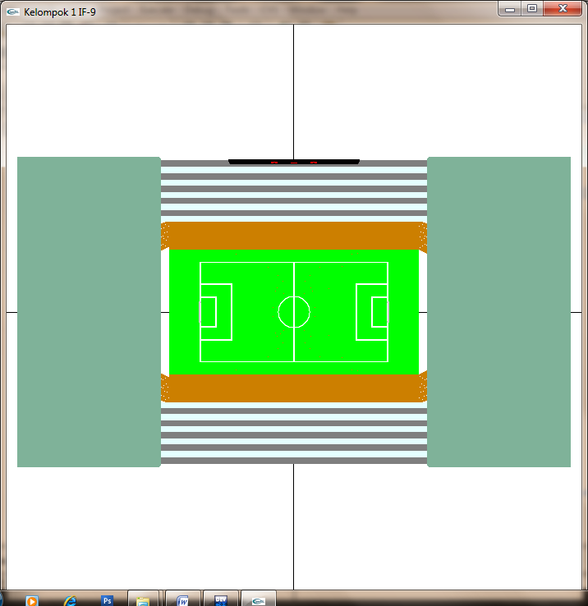

**Gambar 1 Tampak Atas**

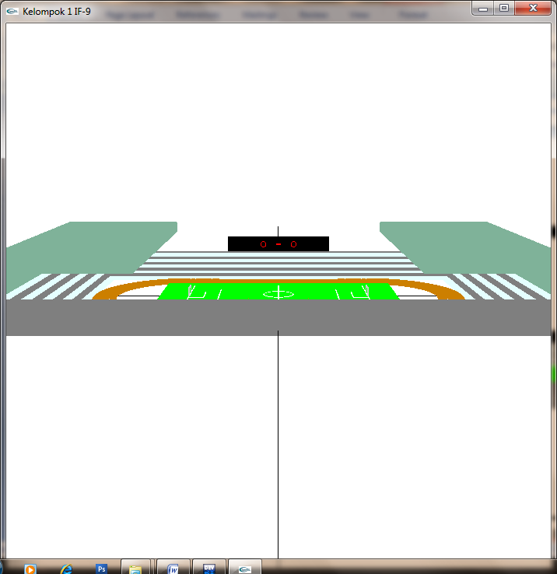

**Gambar 2 Tampak Depan**

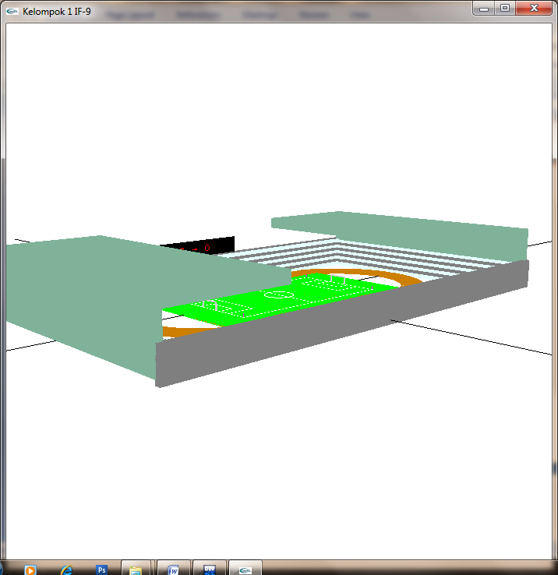

**Gambar 3 Tampak Kiri**

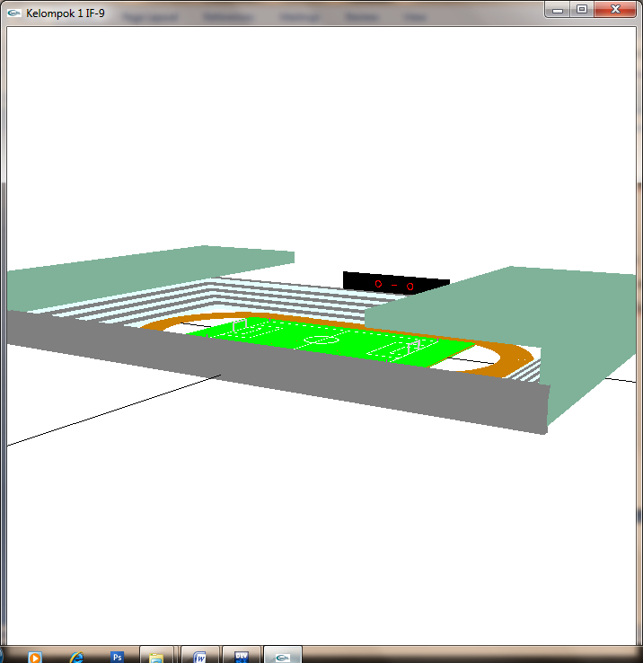

**Gambar 4 Tampak Kanan**

**4. KESIMPULAN**

* Dalam proses pembangunan Stadion Sepakbola ini dapat melatih pemahaman dalam membuat suatu objek nyata kedalam bentuk objek 3D.
* Dalam proses pembangunan Stadion Sepakbola ini dapat melatih otak berlogika.